

CSE PROJECT REPORT

Teacher’s name – Dr. Malvinder Singh Bali

(CSE-326)

Submitted by:

|  |  |  |
| --- | --- | --- |
| S No. | Name | Registration no. |
| 1. | Thota Mohana Naga Venkata Kalicharan | 12304694 |
| 2. | Mamillapalli Abhiram | 12304943 |
| 3. | Peddineni Chandra Vardhan | 12305894 |

**INDEX**

|  |  |  |
| --- | --- | --- |
| **S.NO** | **DESCRIPTION** | **PG.NO.** |
| 1 | Introduction | 2-3 |
| 2 | Technologies Used and Features of the Project | 4-7 |
| 3 | Snapshots | 8-11 |
| 4 | Modules | 12-15 |
| 5 | Conclusion | 16 |

**Project Report:**

**Web Page On: Medical Appointment Booking.**

# **Title Page:**

**Web Page on Medical Appointment Booking-WellCare**

**Introduction:**

The online platform for medical appointments serves as the convenient hub connecting users with a wide array of the healthcare services. Through an intuitive interface, patients can effortlessly schedule appointments, manage their healthcare needs, and receive timely reminders. The website streamlines the entire process, from selecting medical services to the confirming appointments, providing a seamless healthcare experience. With features such as real-time appointment tracking and patient reviews, it enhances user satisfaction. This report delves into the website's functionality, user experience, and the impact of technological integration on the evolving landscape of online medical services. Our goal was to create a user-friendly platform that facilitates easy navigation, all while incorporating a theme that resonates with the medical field.

**Index Page:**

The index page is a comprehensive display of the Wellcare hospital website, featuring a navigation bar, many sections in the nav bar they are Home, About, Service, Doctors, Departments, Blog, Book. Every sections has their own use. In every particular sections mentions the speciality of our hospital and we have logo of our hospital in the index page and the image of the doctors, search option in the index page. This all items comprises the Index page

**CSS Styling**

The CSS styling enhances the visual appeal of the pages, employing a clean and modern design. It defines fonts, sizes, and colors for different elements, ensuring consistency throughout the website. The navigation bar is styled for easy navigation, and product images have interactive features on hover.

Overall, the combination of HTML, JavaScript, and CSS creates a user-friendly and aesthetically pleasing environment for visitors to explore and interact with the WellCare hospital website.

**Technologies Used:**

1. HARDWARE USED
2. SOFTWARE USED

1.Hardware used:

1. Asus Vivobook s15 oled 2023,intel core Evo i5-13500H 13th gen,15.6(39.62cms)
2. Lenovo ThinkBook 15, G-5 intel core i5, 12th gen, 15.6-inch(39.62)
3. Apple 2022 MacBook Air laptop with M1 chip: 34.46(13.6inch)

2.Software used:

1. Text editor used: Visual Studio Code+ Extension = live server
2. Browser used: Microsoft Edge+

Google chrome

3.Programming languages used:

HTML + CSS + JAVASCRIPT

**Features of Project:**

In this website we will get the Medical appointment Booking. This medical appointment booking is in the main hospital named WellCare. This WellCare hospital website gives the user interactivity with the patients.

**1. User friendly interface:**

Dive into the features of the WellCare hospital website. You can get the service 24/7. This website is made up of the friendly interface. In which you can understand the every part of our website. In the navigation bar you can get link to every section of the website. If you want to go into the Doctors section it is available website you can click the Doctors link in the Navigation bar.

**2. Effortless Navigation: Less time appointment booking is provided:**

Navigating the wellcare hospital website is very much easy to the patients or customers. You can go into sections easily there are many sections in the navigation bar it self, Home section gives you the home page, About page can be viewed by clicking in to the about link available in the navigation bar, Service page can be viewed by clicking in to the about link available in the navigation bar, Doctors page can be viewed by clicking in to the about link available in the navigation bar, Departments page can be viewed by clicking in to the about link available in the navigation bar, Blog page can be viewed by clicking in to the about link available in the navigation bar, Book page can be viewed by clicking in to the about link available in the navigation bar

**3.Resposive Web Designing:**

The website is designed to be responsive, ensuring optional viewing in the webpages in many devices, the web designing used in the website done by the technologies called HTML5, CSS, JavaScript. This technologies make the website to be more responsive in the real-time. Many things in website is been clearly specified as per the customer reviews and interaction. Thus we can say that our website is more responsive. So we call our website as Responsive Webdesigning.

**4. Real-Time Appointment booking Keeping You Informed Every Step of the Way**

Appointment booking in this website is very easy and can be done in few steps. At first we should go to the home page, In the navigation bar you can see a option named Book, click the link book and it will redirect you to the booking page. In the booking page you should enter your name, email and the health issue you are suffered.

**5. Customer Support: Your Dedicated Companions on the Medical journey:**

In this website we have provided our email and you can give the suggestions and the reviews and the improvements should be done in the website. By reading the reviews we can improve the website and the facilities in the hospitals and the modifications done on the hospital. By this way we can say that our hospital website is more dedicated to the customer services.

**6. 24/7 Accessibility in the website:**

Our website gives access 24/7. You can access the website every time when you want it, our website says if you had any fear regarding the health issue then don’t fear our WellCare hospital website is there. This will reduce the time of waiting at the hospital and we can give our best customer care at the customer desk.

**Some Screenshots of the Project:**

**1.Main page:**

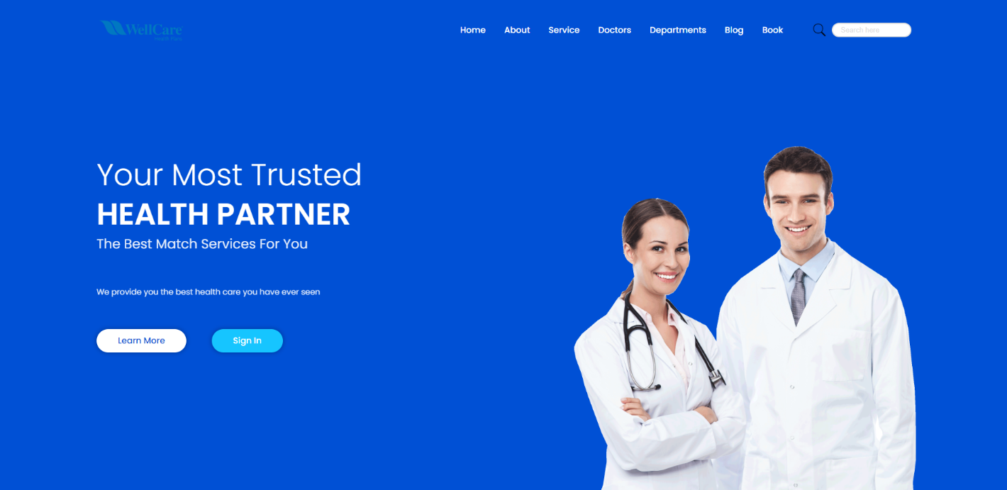

**2.About page:**

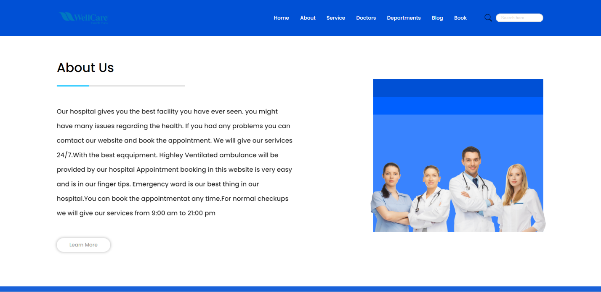

**3.Services page:**

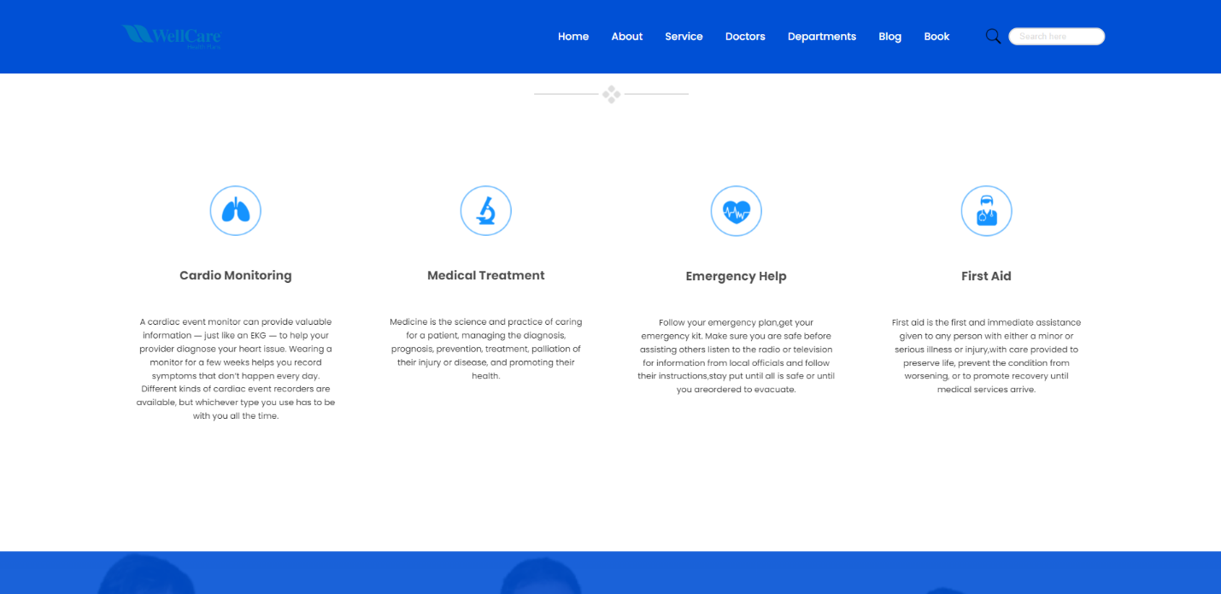

**4.Doctors page:**

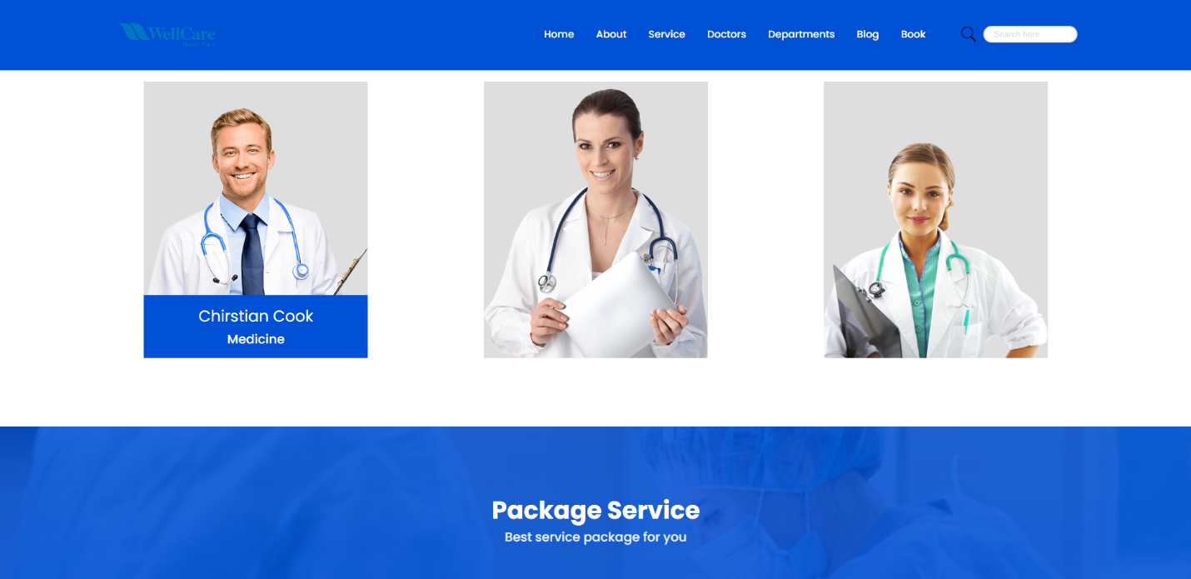

**5. Departments Page**:

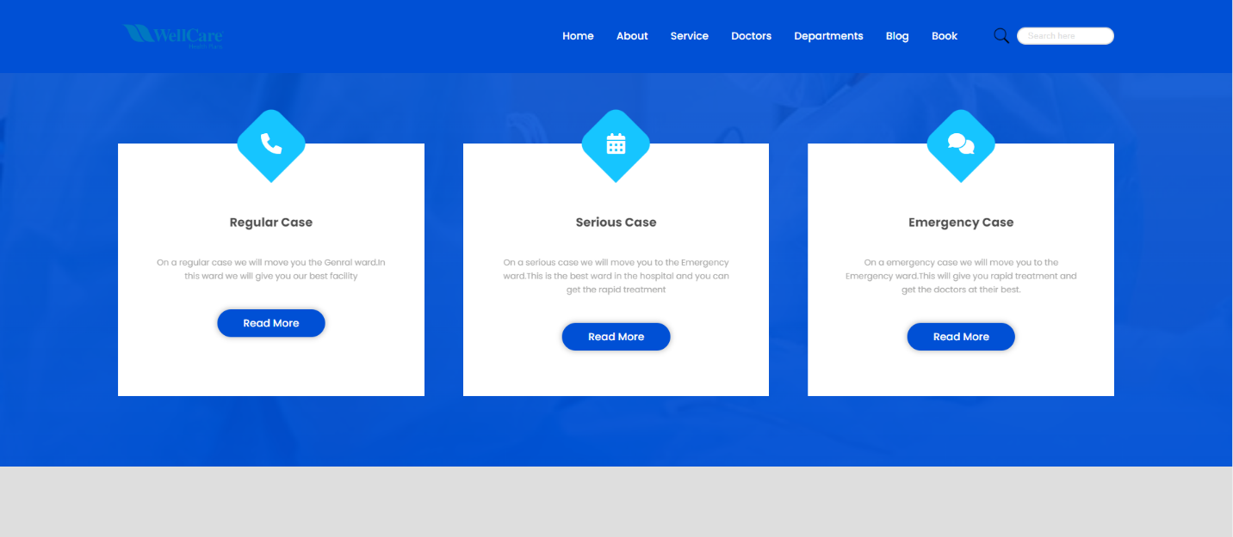

**6.Blog page:**

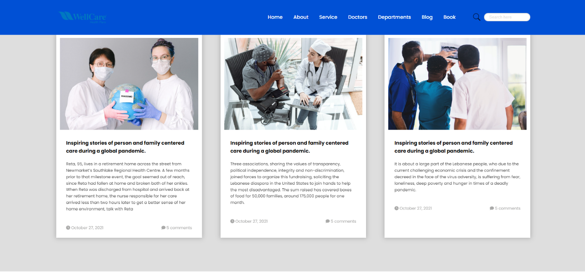

**7.Book page:**

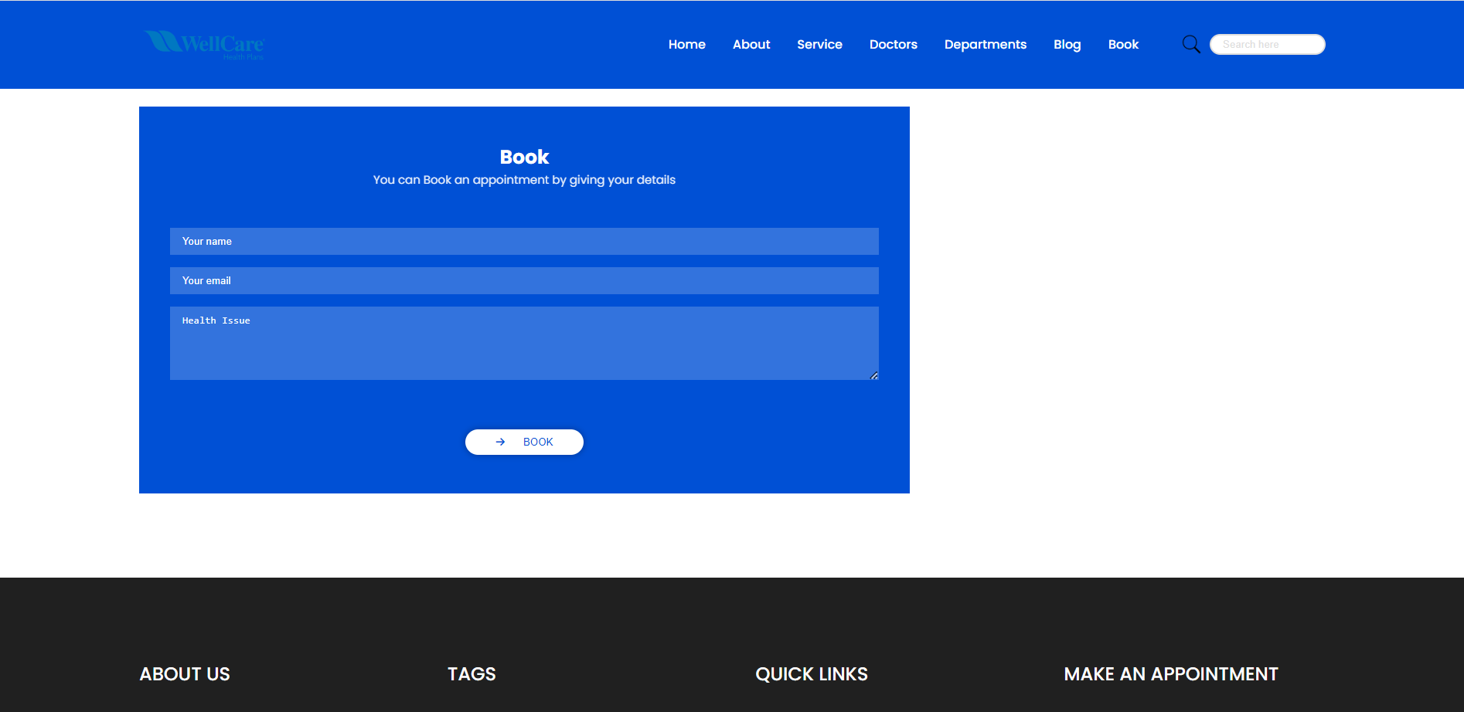

**5.About us Page:**

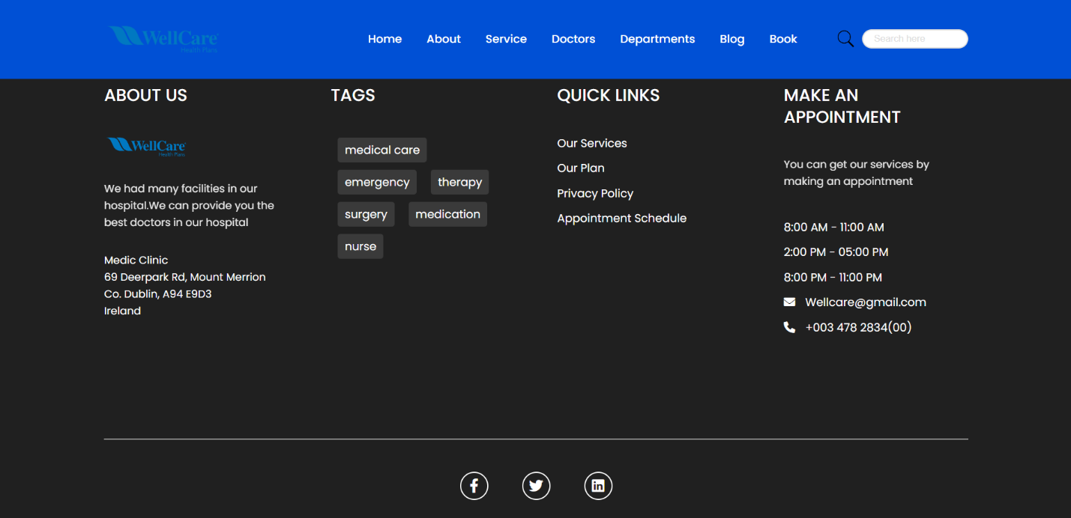

**MODULES:**

Home **:**

In the Home page you can get some information of our hospital, As if you open our website at starting of it you can see the home section of the page which comprises with the information of our hospital.

In the home page you can see the navigation bar which consists many sections, you can go into those sections by just clicking it in to. After the sections you can see a search bar which help you to search things in the webpage.

After the navigation bar there is a picture of the doctors and the logo of the hospital. After the picture there is a quotation of the

Our hospital. After that you can see the learn more button and sign in button in which you can sign in.

These all the things comprise the home page of the webpage.

ABOUT:

This section in the webpage gives the additional information about the hospital and the services of the webpage, this is a brief introduction page in which it gives the info of the webpage and the hospital.

SERVICES:

This section in the webpage gives the information about the services that are provided by our hospital. Some of the services like cardio monitoring, Medical Treatment, Emergency help, First aid these are the services provided by the hospital, every service is explained in detail.

DOCTORS:

This dedicated section gives the information about the doctors, these doctors are the specialists on their specific departments, The images of the doctors are given on the section and if you put the cursor on the image of the doctor you can get and the department of the doctor is known to us.

DEPARTMENTS:

This section provides information of the departments available on the website, in this section you can get the departments of the hospital they are Regular case, Serious case, Emergency case. Under these section you can get the department.

Blog:

This section provide information of the recent posts of the inspiring stories of the person and family centered care during a global pandemic.

This section provides the information of the inspiring stories, the family centered care during the global pandemic

Book:

This section of the webpage comprise the main theme of the webpage, i.e. booking an appointment of the hospital.

This section make the appointment of the hospital in a easy way which is user friendly.

FLOW OF PROJECT:

The project team is given the moto of the webpage, by that every one get to know the theme of the website, and every one is given particular sections to do and they used to code for the given sections by that work began easy. The project development flow encompassed the following stages:

Planning:

Clearly define the scope, goals, and requirements of the project.

Prioritize creating a user-friendly Medical Appointment Booking.

Select a color scheme aligned with the overarching theme.

Development:

Simultaneously implement frontend functionalities to ensure a clear hospital website.

Testing:

Conduct thorough testing to identify and rectify any bugs or issues.

Manage the visual appearance of web pages by applying diverse combinations of codes and decorations.

Documentation:

Document the codebase, functionalities, and user guides for future reference and understanding.

This agile approach ensures a streamlined and efficient process for developing the Medical appointment booking, with a focus on user experience, functionality, and meticulous testing to deliver a reliable and visually appealing Medical appointment booking.

**Conclusion:**

In conclusion, the utilization of HTML and CSS in our medical appointment booking project forms the robust foundation for creating an making pleasing and user-friendly interface. HTML's structural capabilities provide a logical organization of the content, while CSS elevates as visual appeal with consistent branding and responsive design. Together, they contribute to a seamless and accessible user experience. The combination of these technologies not only ensures cross-browser compatibility and rapid development but also facilitates cost-effective and scalable solutions. In essence, the harmonious integration of HTML and CSS lays the groundwork for a efficient, visually engaging, and user-centric medical appointment booking website.